29  1st Sunday of Advent  Attend Mass is person or view online. | 30  Romans 6:23 | 1  Galatians 4:4-5 | 2  Say a Prayer for someone in need. | 3  Isaiah 7:14 | 4  Isaiah 9:6 | 5  Isaiah 11:1 &  John 15:1
6  2nd Sunday of Advent  Thank God for something special in your life. | 7  Luke 2:17-20 | 8  Say an Act of Contrition | 9  John 3:16 | 10  John 5:11 | 11  Pray the Rosary | 12  Matthew 2:1-2
13  3rd Sunday of Advent  Matthew 2:10 | 14  Send a Christmas card to a friend. | 15  Luke 2:9-12 | 16  Luke 2:15-16 | 17  Recite the Hail Holy Queen | 18  Philippians 2:8-10 | 19  Romans 6:23
20  4th Sunday of Advent  Put your electronic devices away for a day. | 21  James 1:17 | 22  Colossians 1:15-18 | 23  Revelation 5:6-10 | 24  Reflect on the birth of Jesus in the Nativity | 25  Merry Christmas!
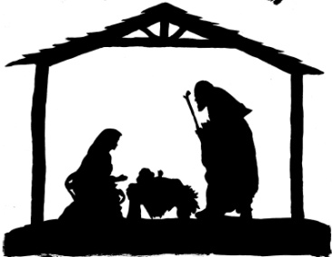
2020
ADVENT CALENDAR

